**My API Information**

https://fakestoreapi.com/this my assignment API. From cloud API

<https://fakestoreapi.com/products>

Here is the API send these response -

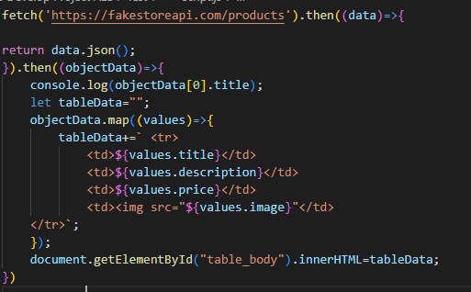

Fig. 1 API json Array file

**Goal:**

Fetch these meta data and show in an html table.

**Description:**

Then in script tag we fetch their post API. From fetch we get the response of their API. Initially I get the whole response Array because API has many meta data. But I need to focus only the post id, post title and post body.

First I create header <title> Api Data in table </title>

Then I create Table structure where data will fetch by API data come to me as JSON object

When get the data then I just typecast in the JSON from .

Then I check the data in console log. Then I map the data because JSON use

Key-value format and map also use same format.

Then according to my HTML table format I create a table for displaying data .

Fig. 2 JS part

**Final Output:**

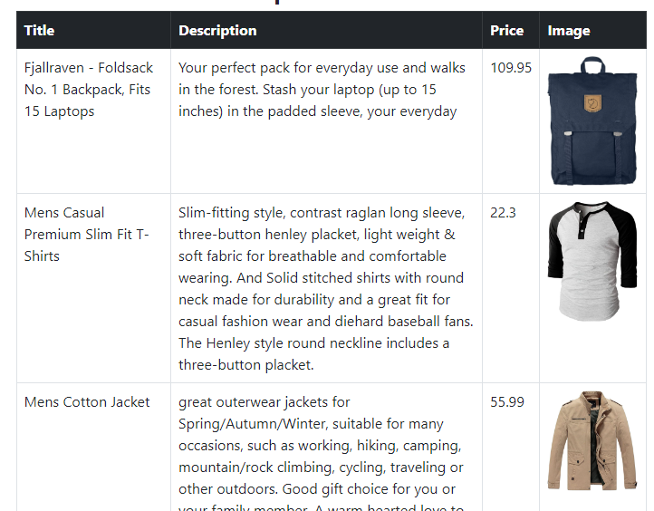

Fig. 3 Final Output